**Car Rental System**

Aya Ali Naga 6376

Mahmoud Adham Mahmoud 6544

Moustafa Hesham 6600

Mostafa Tamer 6517

Contents

|  |  |  |
| --- | --- | --- |
| Section | Title | Page |
| 1 | User side | 2 |
| 2 | System side | 7 |
| 3 | Database | 10 |

1. **User side**

Implemented features:

Figure 1.1

1. 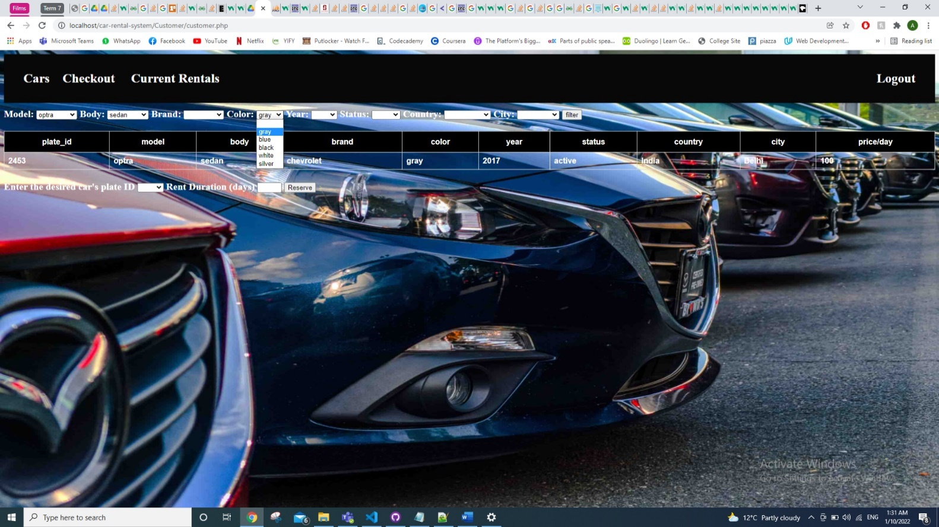The user can search for any of the car specs (model, body, brand, colour, year, status, country of office, city of office) they desire and filter the car’s shown to display only the ones with the required specs. Figure 1.2 shows a demonstration of this.

Figure 1.2

1. The user can reserve any car of the available cars and specify how long they wish to rent it for. A user can reserve multiple cars at once by choosing each one and clicking the reserve button.
2. Two payment methods are available once the user proceeds to checkout: cash and credit. If credit is chosen, then the user must input their credit card pin.
3. The user can view their current rentals, which specifies the car they rented along with the rent date and return date and price.
4. The cars that have been reserved but not yet paid for are displayed for the user to see, with the option of the payment method.
5. Once a car is returned, it is removed from the ongoing rentals of that user.

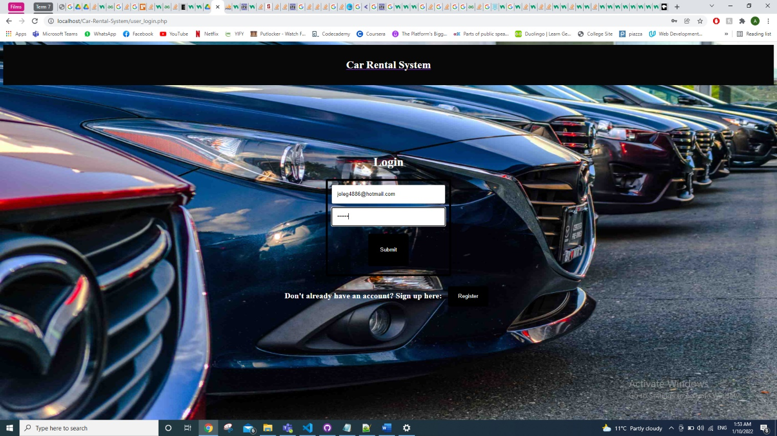How it works:

1. Login screen

The login screen asks for the email and password if they already have an account. The admin has an email and password of their own, so once an admin logs in, they are taken to the system’s page. If a customer logs in, they are taken to the customer’s page. If a user would like to register, they click on the register button which directs them to the register page.

Figure 1.3

1. 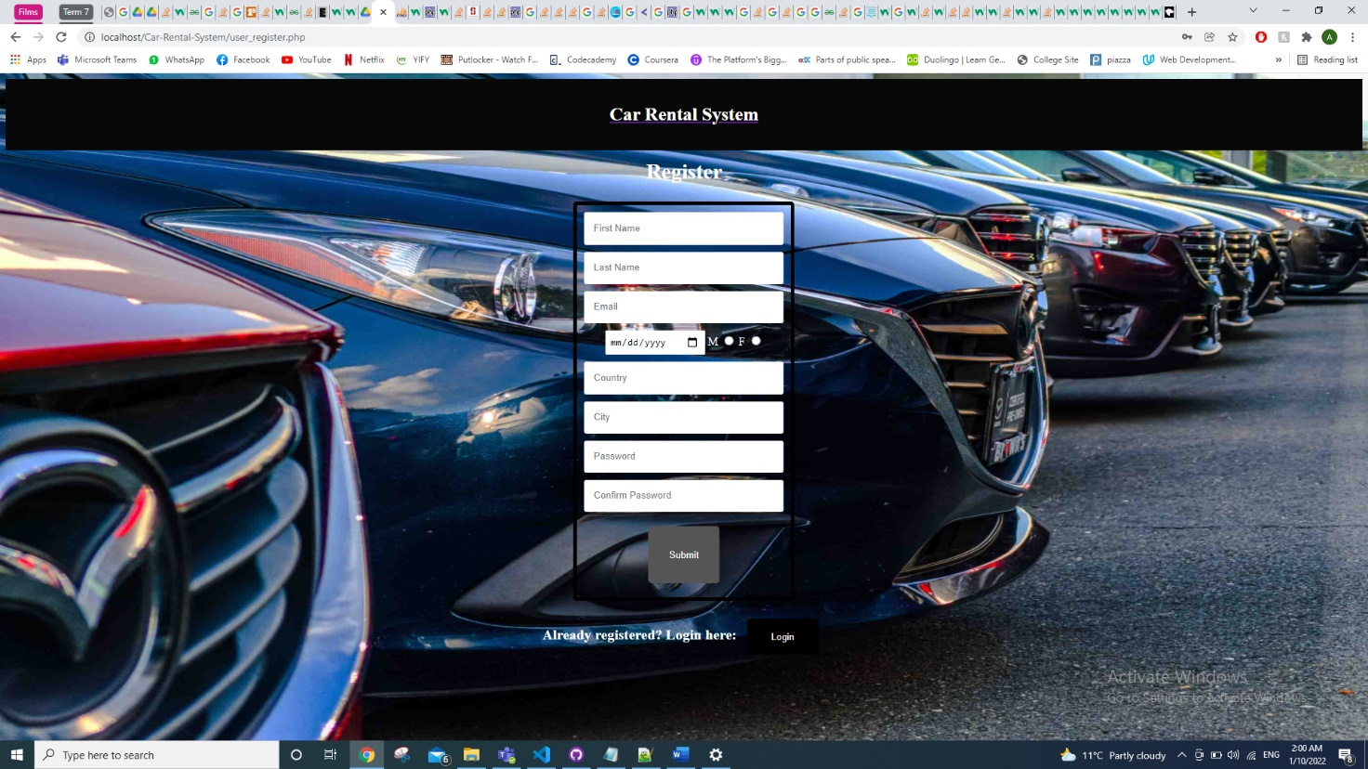Register screen

Figure 1.4

The register page takes in information of the user and once they submit, it is saved in the database in table users. The email is checked to see if it already exists in the database. If it does exist an error message will pop up. If it does not, the user is directed to the customer’s page.

1. Customer’s screen

Figure 1.5

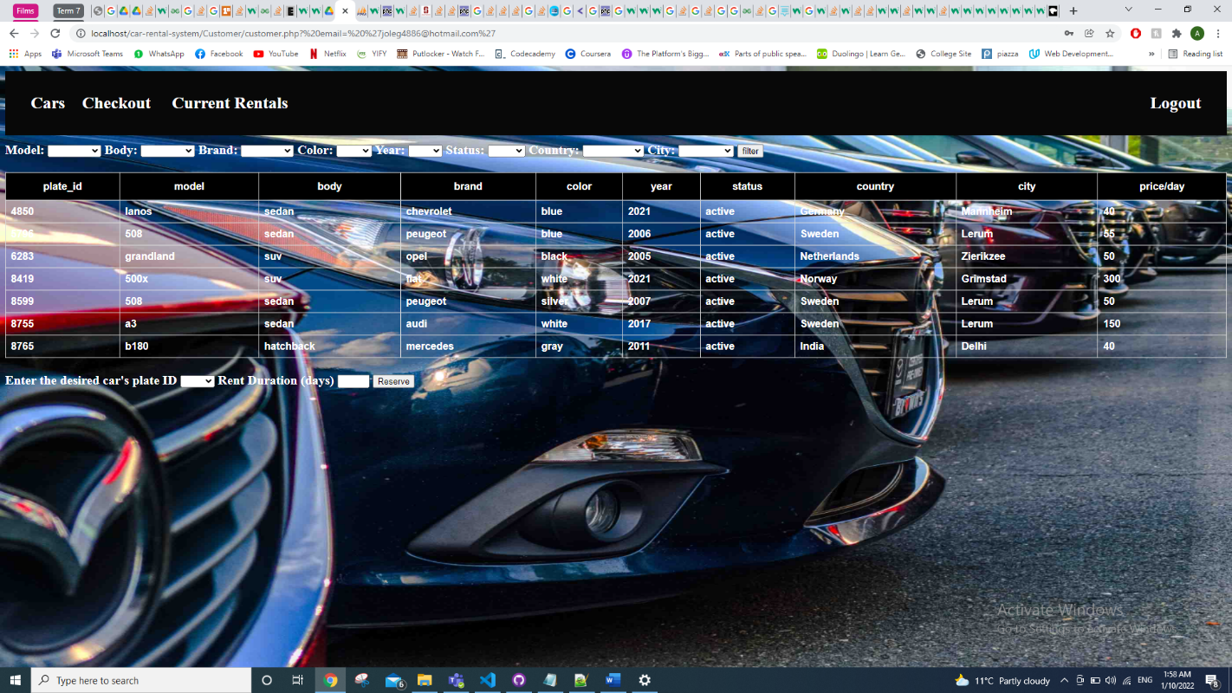

The cars that are not reserved are displayed to the customer as shown in figure 1.5. The user can filter the cars according to their specs. Any new car that is added will appear in the page and in the drop-down menus for the specs as the cars are taken from the database from the table cars. The customer can choose the plate ID of the car they wish to reserve and choose the duration. Once they click the reserve button, the car will no longer be available for any other user until it is returned. The customer can then click the proceed to checkout button, shown in figure 1.6, to be redirected to the checkout page.

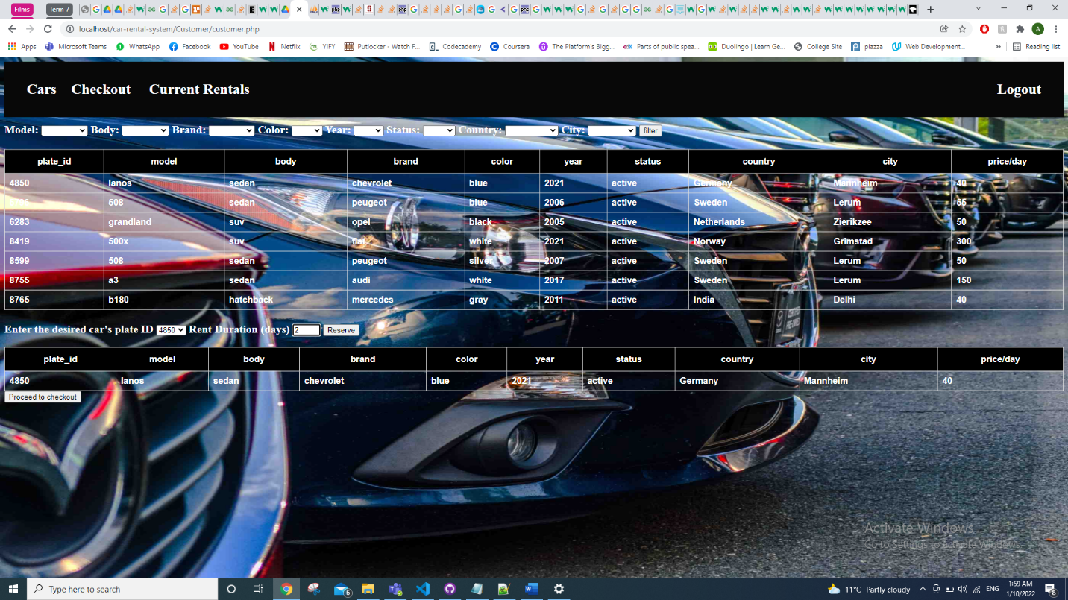

Figure 1.6

1. Checkout screen

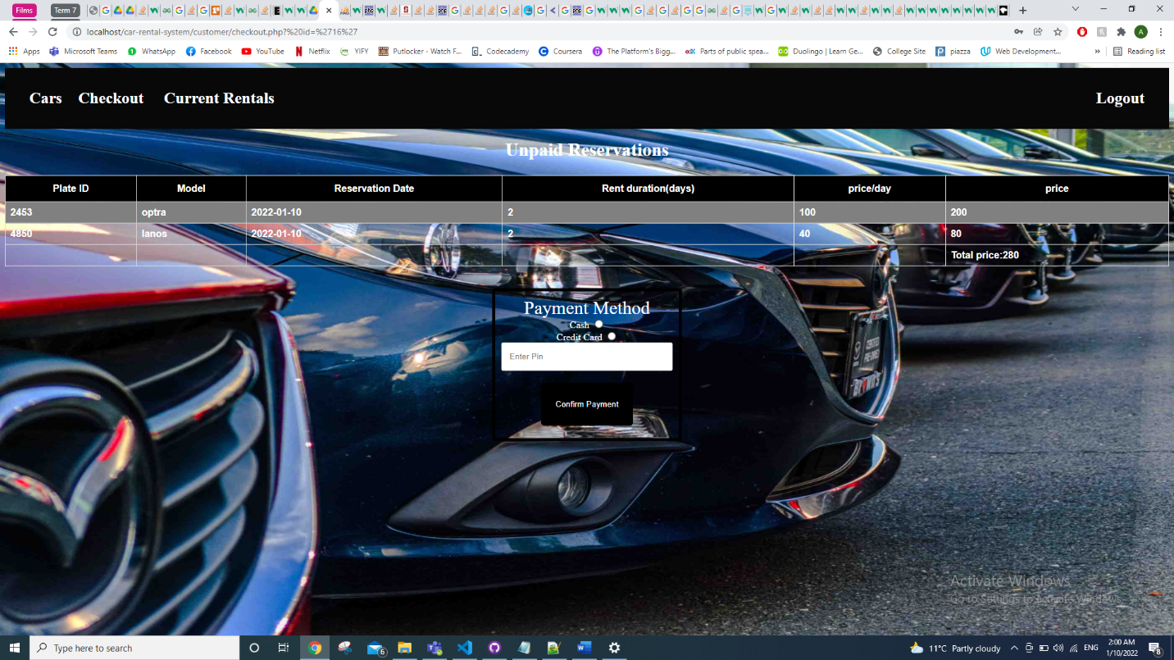

Figure 1.7

The unpaid reservations are displayed to the user with the cars that are reserved along with the details of the price and duration. The user chooses a payment method to pay for all the cars that are unpaid for. Once the car is paid for, it is removed from the unpaid reservations. The user can still view the car from the current rentals page, as long as the return date has not passed.

1. Current Rentals screen

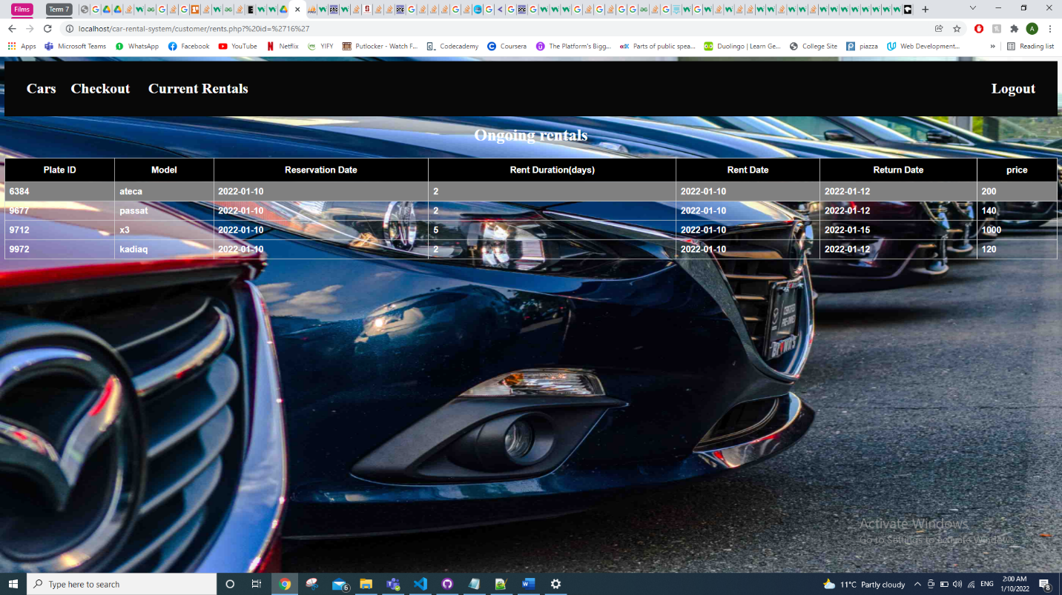

Figure 1.8

The current rentals screen displays all the ongoing rentals this user has by checking the table reservation in the database. It displays the rent date and the return date along with the car model and price for the whole duration. When the return date passes, the car is removed from ongoing rentals and back into the customer page where it is once again displayed for all customers.

1. **System side**

1- The admin logs in, using the same screen as a customer, with an admin user. (is_admin=1 in table user)

2- The admin is sent to system_cars where all cars are listed like in Figure 2.1.

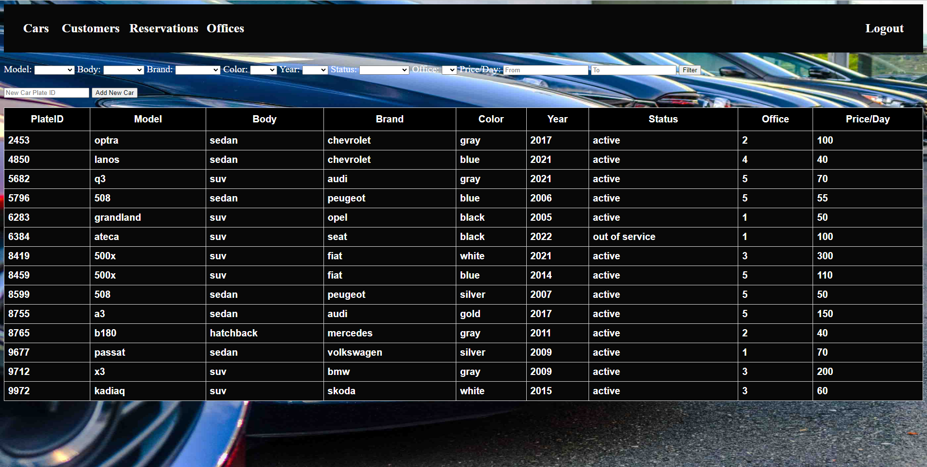

Figure 2.1 system_cars

3- The admin can also filter the cars like the customer.

4- Admin can add a new car after providing its plate id in the text box. The car will be added to the database immediately with the given plate id and empty or null values for other fields. Figure 2.2 shows the result of clicking “Add New Car” using “1111” as plate id.

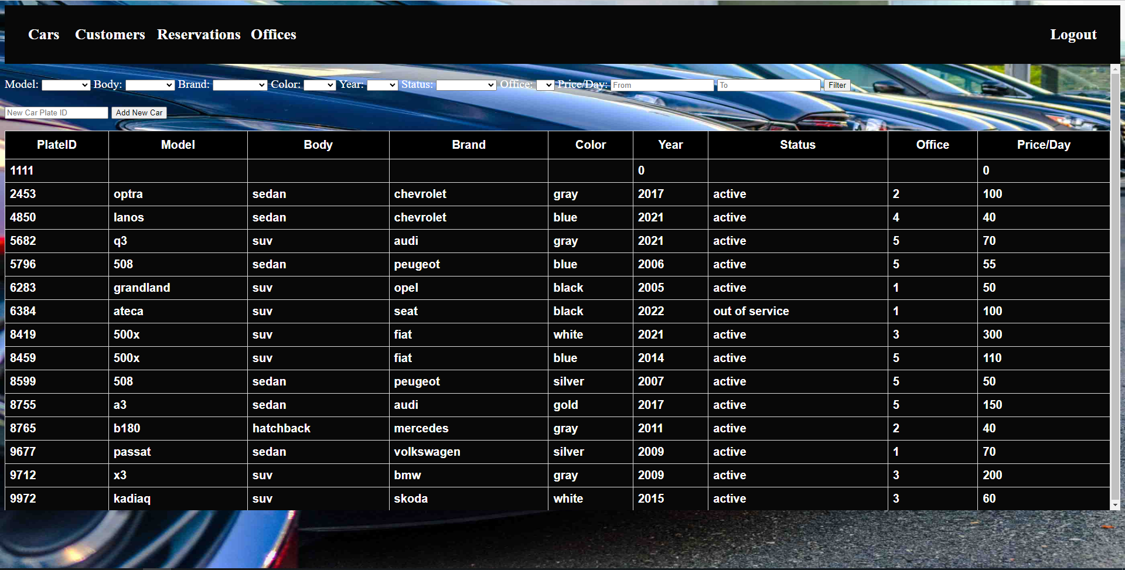

Figure 2.2 new car added

5- The admin can then edit any car information and the system will save it to the database using ajax.

6- Admin can also view customers, reservations, and offices. And filter the results for each, as shown in Figure 2.3, Figure 2.4, and Figure 2.5.

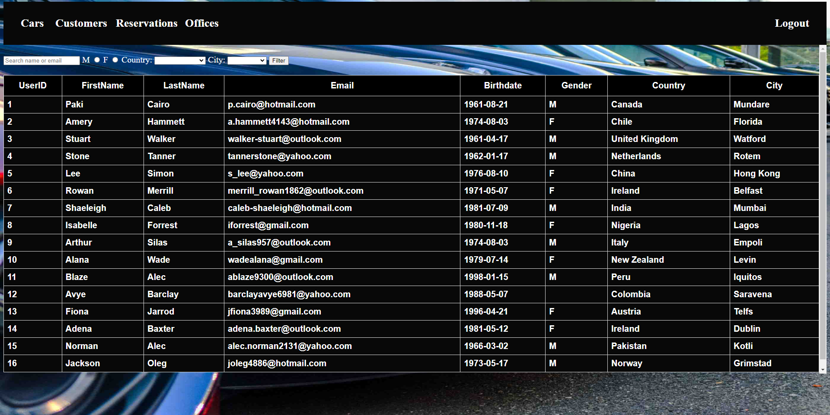

Figure 2.3 system_users

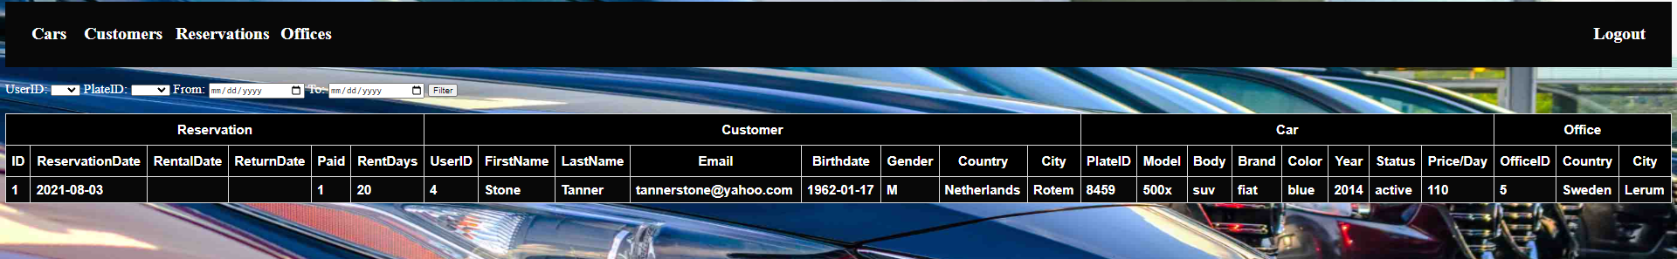

Figure 2.4 system_reservations

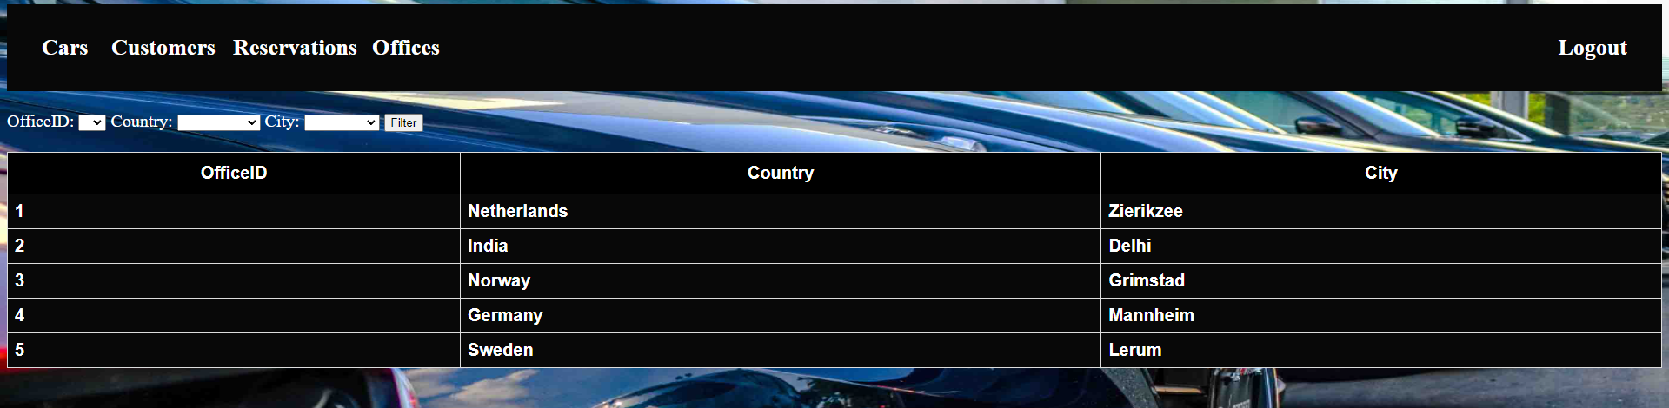

Figure 2.5 system_offices

1. **Database**

1- We created 4 tables in the database (car, user, reservation, office)

2- car:

* plate_id as PK
* office_id as FK
* basic car information
* price per day
* status as active or out of service

3- user:

* user_id as PK
* basic information
* is_admin as Boolean to indicate whether user is admin or customer during login

4- reservation:

* user_id as PK1, FK1
* plate_id as PK2, FK2
* office_id as PK3, FK3
* reservation_id as UNIQUE

5- office:

* office_id as PK
* country and city of office

6- Figure 3.1 shows the erd diagram for the database.

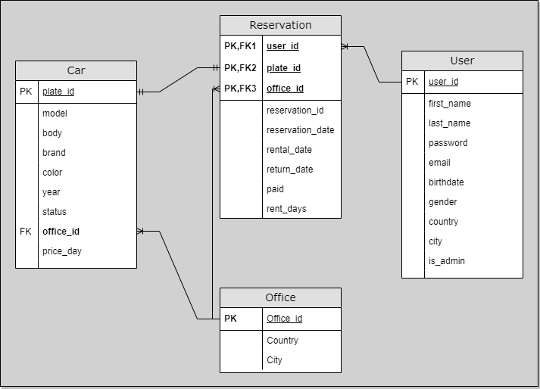

Figure 3.1 ERD for Car Rental System Database

7- DML: We generated random information for all tables for testing.